

AADHAAR AUTHENTICATION ECOSYSTEM PROJECT, DEPARTMENT OF INFORMATION TECHNOLOGY & COMMUNICATION, GOR

February 23, 2024

User Manual for Raj-UPASTHITI Mobile APPLICATION (Employee MODULE)

Contents

1. Raj Attendance: 2

2. Home Screen 2

3. Login as Employee 3

4. Mark In Attendance 5

5. Mark Out Attendance 8

6. Marking as Out of Office 11

7. Marking as On Leave 12

1. Raj Attendance: Raj Upasthiti application provides an Aadhaar enabled platform to government employees/College Students to mark attendance. Attendance system enables an employee/College Students to register attendance by simply scanning the Face using smartphone camera. This event is authenticated online after one-to-one match with the Face biometric attributes stored in the UIDAI database against the employee/College Students’ Aadhaar number. This system provide facility to departments/colleges for on-boarding, employee/student registration and attendance report at centralize location.

# Home Screen

As the application is launched, home screen will be displayed as shown in the image below.

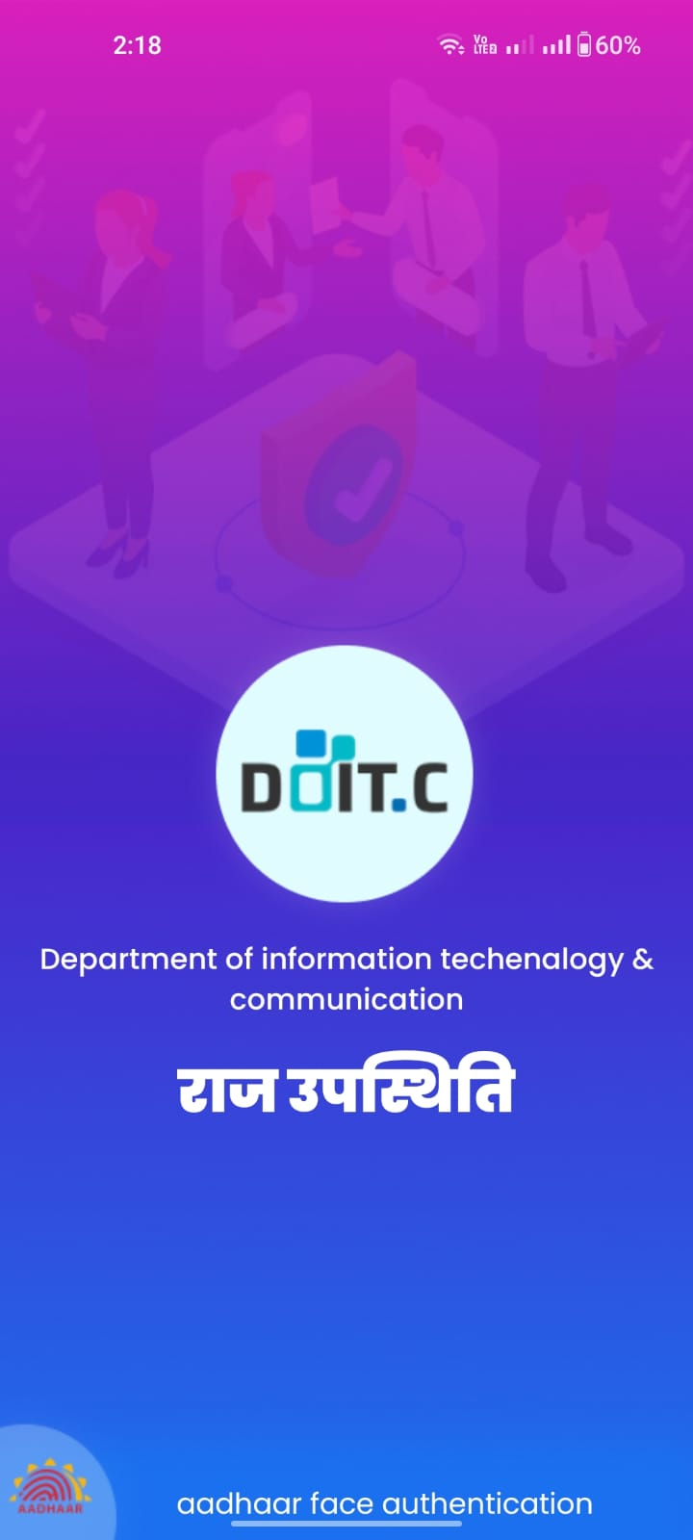

# Login as Employee

* Registered employee can login on the mobile app using SSO ID and Password.

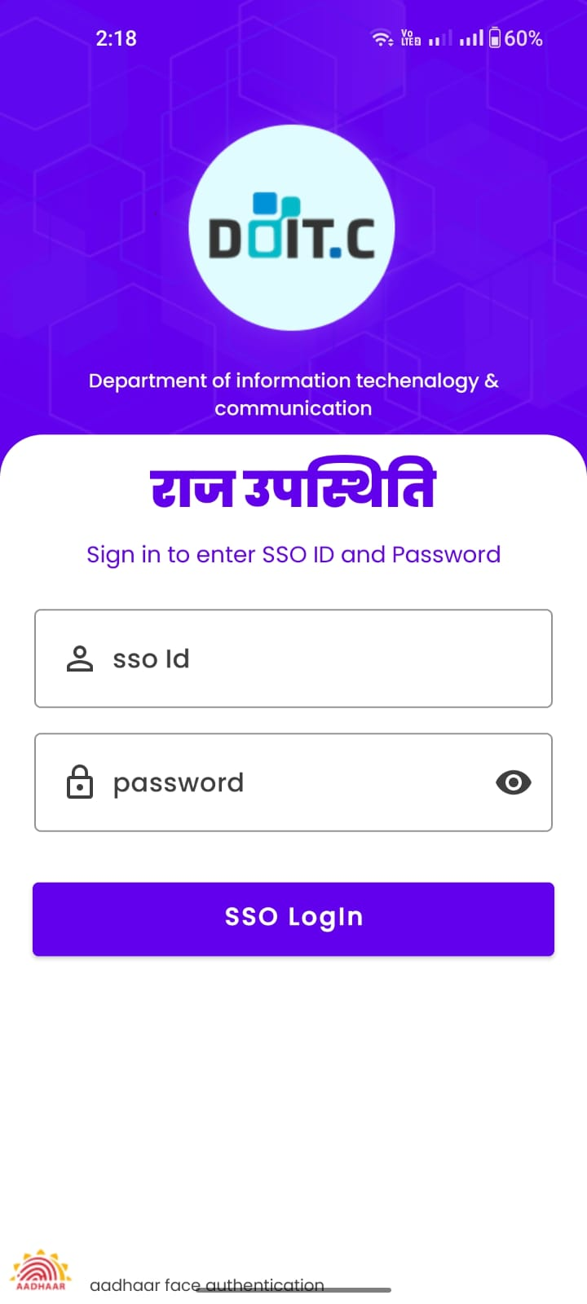

* After successfully login, following screen will be displayed for the employee.

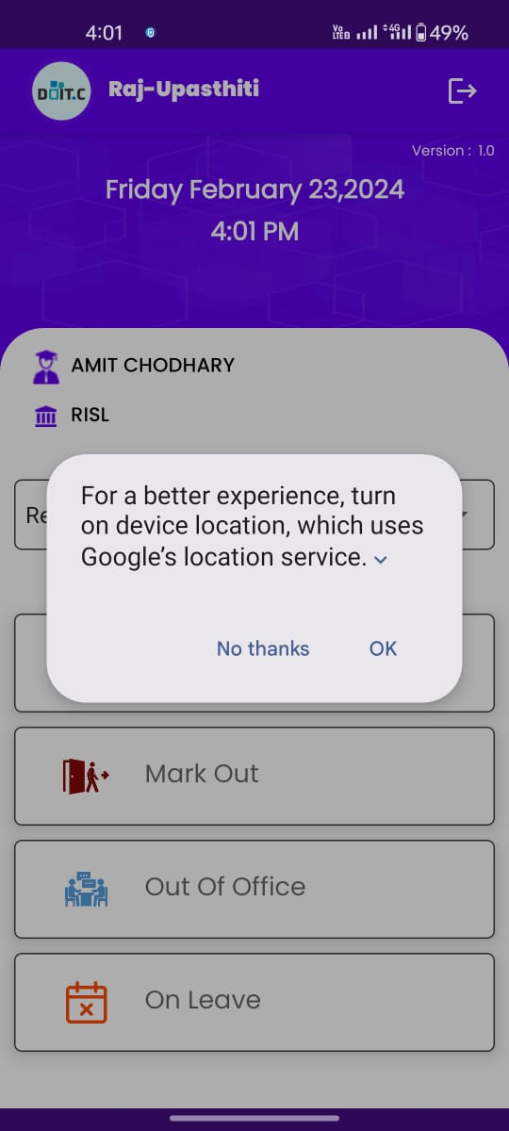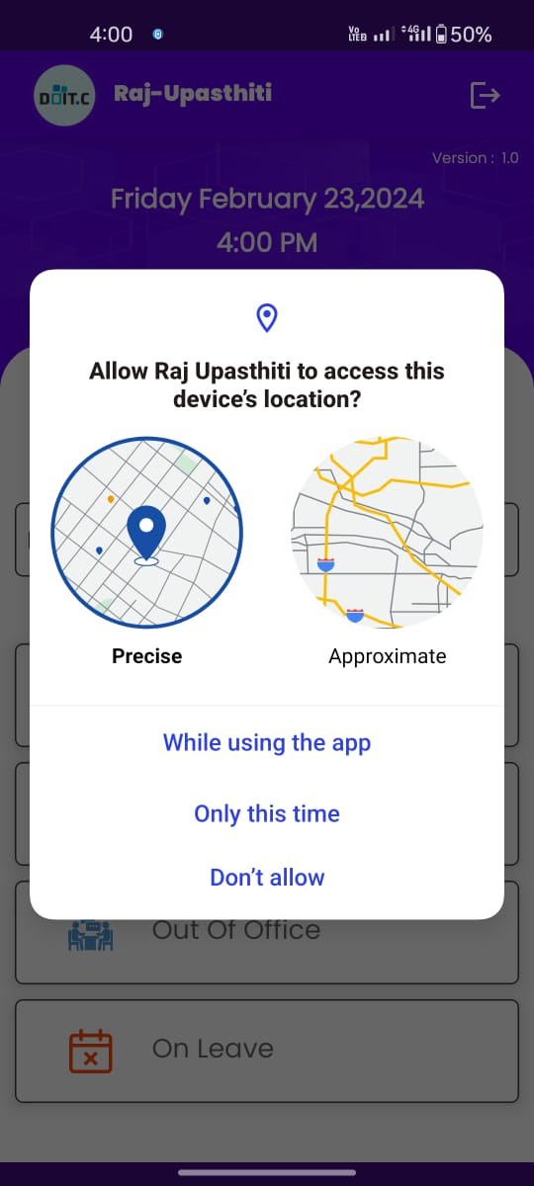

* Employee must allow the location and select either while using the app or only this time
* After turn on the device location, following screen will be displayed.

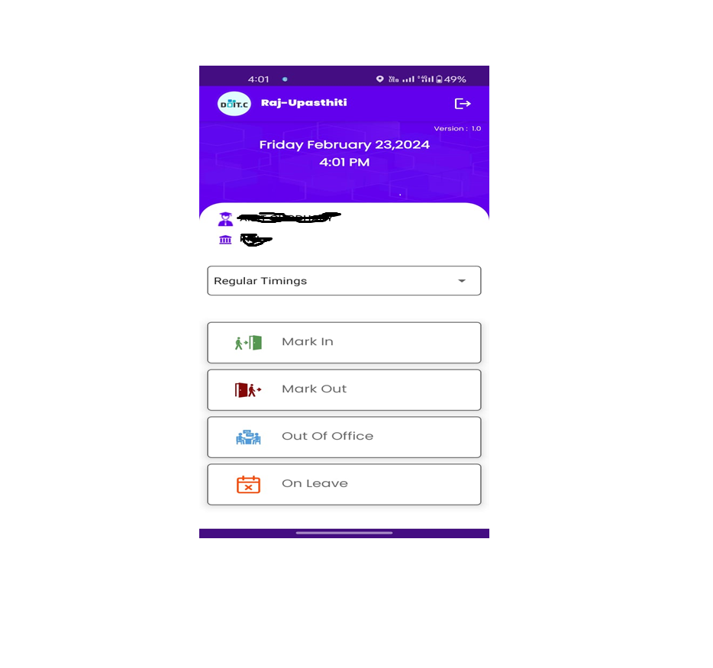

* Employee name and department will be displayed

# Mark In Attendance

* In the Mark In attendance process, employee must select the shift timing i.e. Regular timing, Shift timing (S1), Shift timing (S2) and Shift timing (S3)

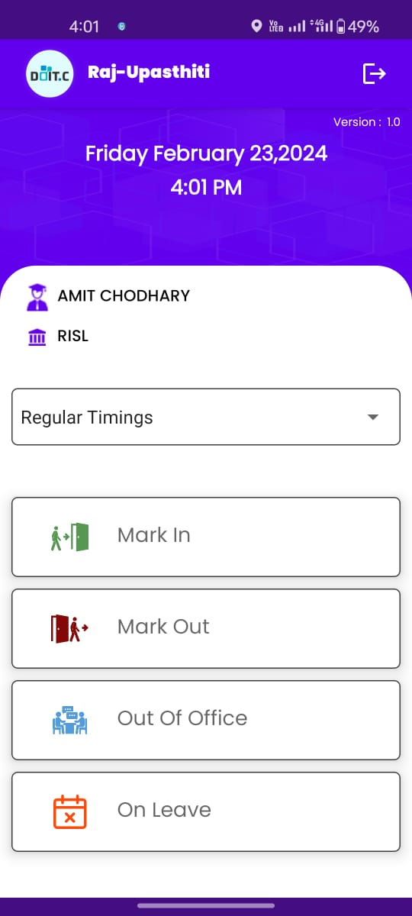

Click here to Mark In the attendance.

* To Mark In the attendance click on the **Mark In** and following screen will be displayed.

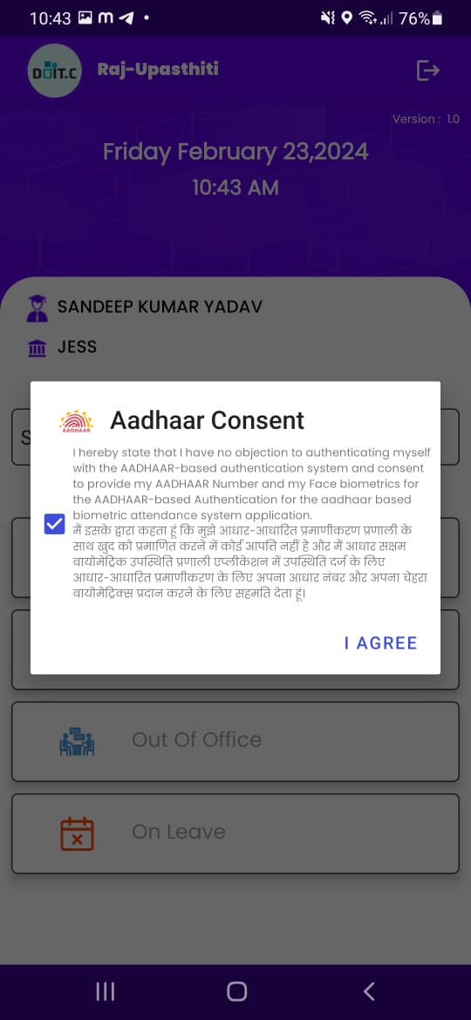

* Accept the consent and click on **I AGREE** to scan Face using camera of smartphone.

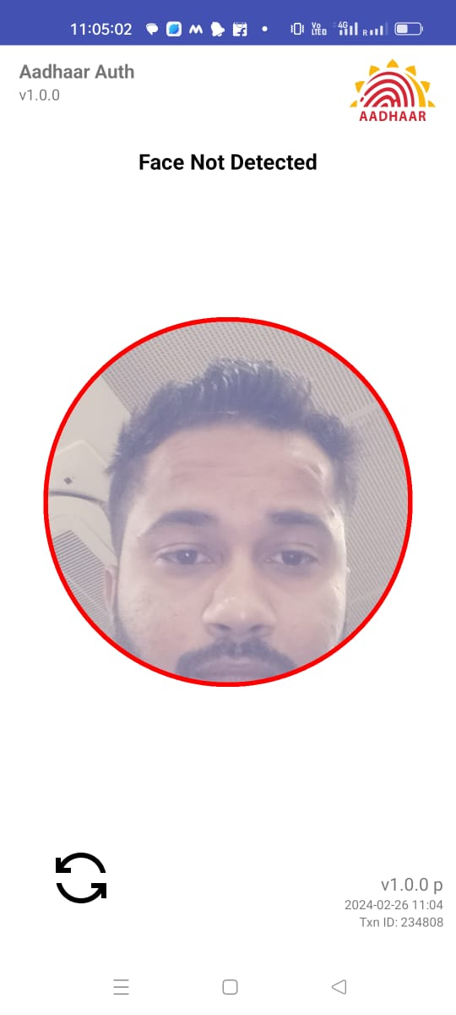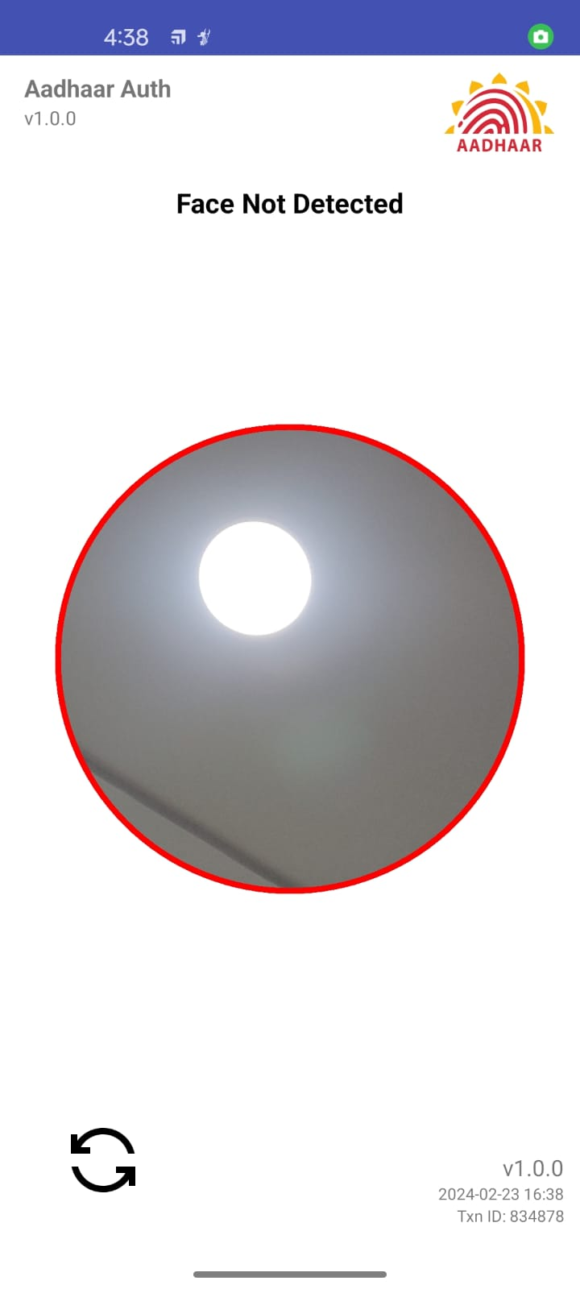

* Employee is required to show his/her face in front of Camera and blink his/her eyes once to capture the Face.
* After successful capture of the Face, Face authentication request will be sent to UIDAI for authentication of Face data against the Face data stored in UIDAI’s database along-with user’s Aadhaar number.
* Upon successful authentication of Face data by UIDAI, following screen will be displayed.

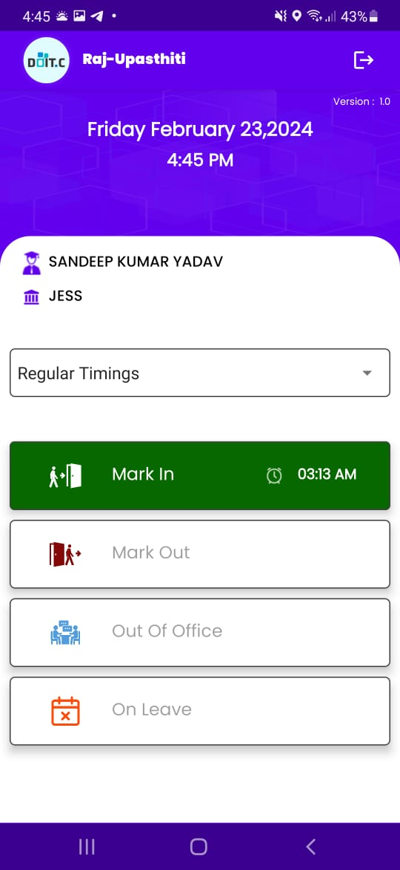

* After successfully marking attendance, the Mark In button will change to a green color.

# Mark Out Attendance

* To Mark out the attendance, employee will click on the Mark out button.



Click here to Mark Out the Attendance

* After clicking on the Mark out button following screen will be displayed



* Accept the consent and click on **I AGREE** to scan Face using camera of smartphone.



* Employee is required to show his/her face in front of Camera and blink his/her eyes once to capture the Face.
* After successful capture of the Face, Face authentication request will be sent to UIDAI for authentication of Face data against the Face data stored in UIDAI’s database along-with user’s Aadhaar number.
* Upon successful authentication of Face data by UIDAI, following screen will be displayed.

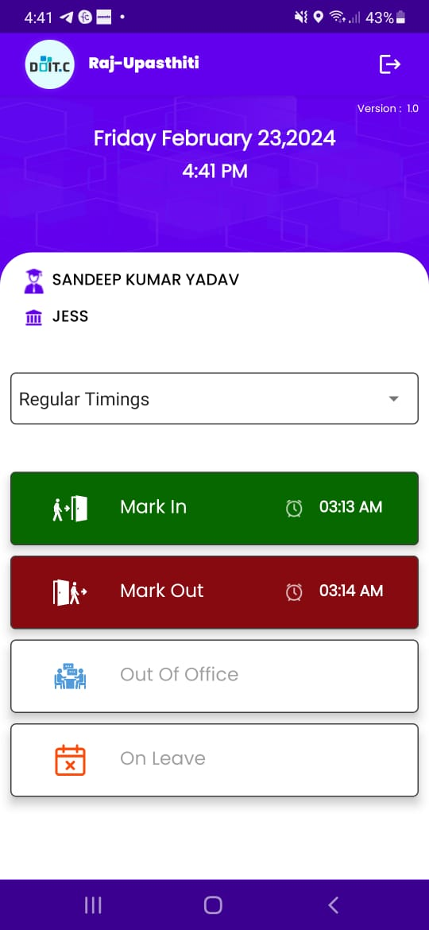

* After successfully marking out attendance, the Mark Out button will change to a red color.

# Marking as Out of Office

* ****Employee will be able to Mark as an out of office, employee will click on the Out of office.

Click here to Mark as an out of office.

* Click on the Out of Office and the following screen will be displayed.

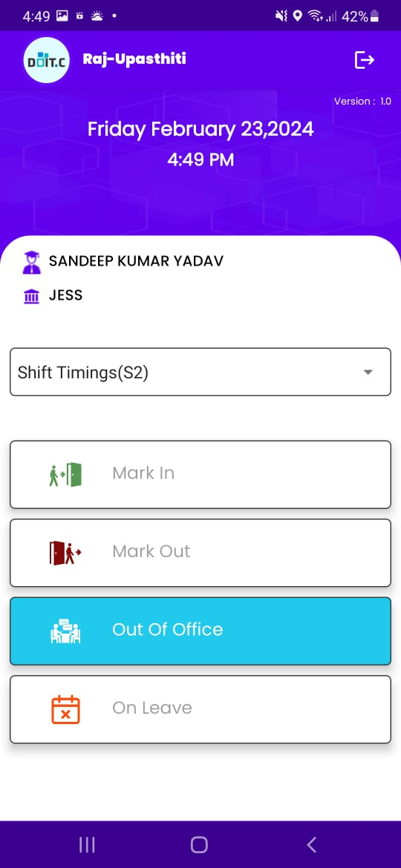

* After successfully marking as an Out of Office, the Out of Office button will change to a sky color.

# Marking as On Leave

* Employee can Mark the leave if the employee is on leave. Following is the process to mark as on leave.



Click here to mark as On Leave

* Employee will click on the **On Leave** button and the following screen will be displayed.

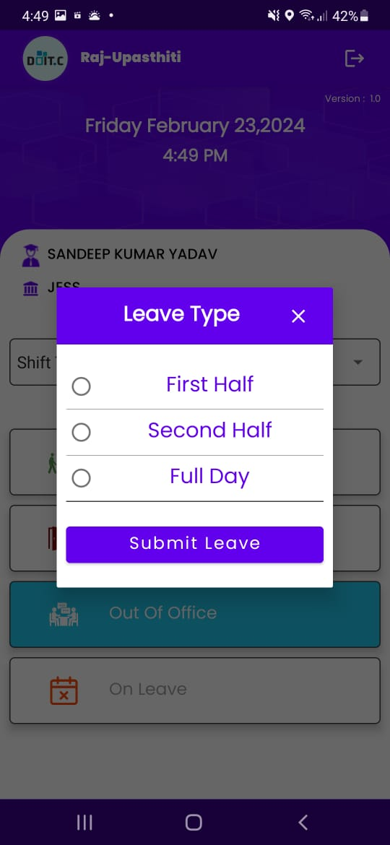

* Employee will select the Leave type i.e. First Half, Second Half, and full day leave.
* Select the leave type and click on the **Submit Leave** button, the following screen will be displayed.

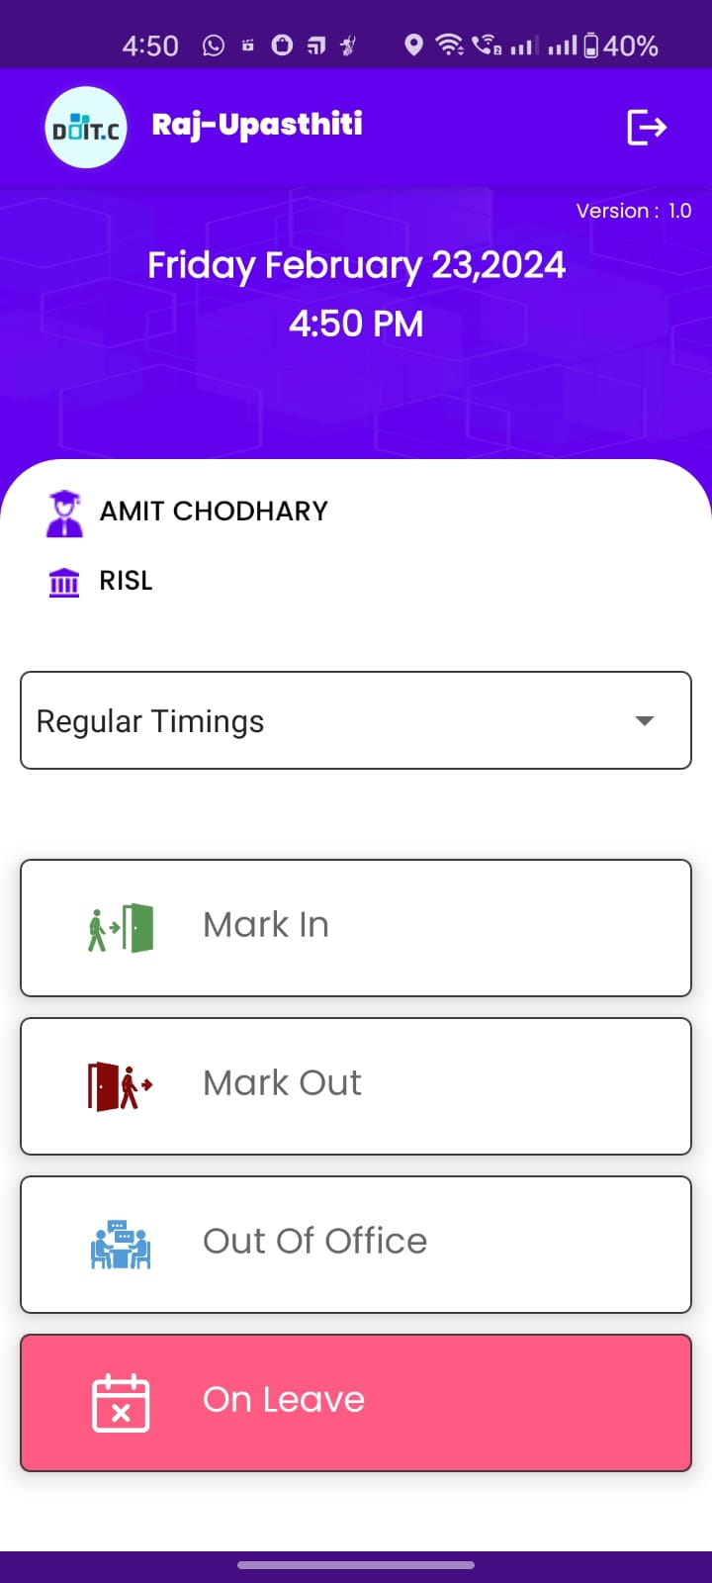

* After successfully marking the Leave, the On Leave button will change to a pink color.

**The End**